CAS Online Registration System – Registration Payment Summary Report – Clubs and PTSOs
The Payment Summary Report has been implemented for both clubs and PTSOs to use.
Clubs will use the report to select batches that have been submitted. Along with the payment, clubs will include the report to identify which batches have been paid with their payment.
PTSOs will use the report to select batches and coach/official payments that have been submitted to CAS. Along with the payment, PTSOs will include the report to identify which batches and payment records have been paid with their payment.
On the list of registration batches, a check box will appear once a batch has been submitted that allows you to select the batch for payment. You can select as many batches for payment as you need. When you have selected the batches for payment, you can click the “Payment Summary Report”. The report will be displayed with only the batches that you have selected for payment. You can print the report or save it as a PDF. This report should be submitted along with the payment. USE the back arrow to return to the previous screen.
NOTE: once a batch has been printed on a payment summary report, an “S” will appear beside the check box. This is to let you know it has already been included on a payment summary report. The “S” does NOT prevent you have selecting it again to include on another payment summary report if required.
For Clubs, once a batch has been submitted (PAYT WAIT status), you can select the batch to include on your payment summary report. If you have multiple batches you want to include, select each batch to include. Then click the payment summary report button.
For PTSOs, once a batch has been submitted (PAYT WAIT (NSO) status), you can select the batch to include on your payment summary report. You can ALSO go to your “Submitted Payments” and select payments that have been submitted (PAYT WAIT(NSO) status) to include on your payment summary report. You can include both batches and payments on the same summary report if you like. Just check the batches to include, go to the payments and check payments to include and THEN click “Print Summary Report”. This can be done from either screen (batch or payments screen). Once printed, the “S” will appear beside those already printed. But again, you can reselect anytime.
NOTE: the “Payment Summary Report” button will only appear if there have been batches or payments selected for printing.

Club Payment Summary Report Screens
List of batches for a club, only “PAY WAIT” (payments submitted by club) can be printed on payment summary report. These will have the check boxes beside the ”Go” button. You can check these on and off as desired.

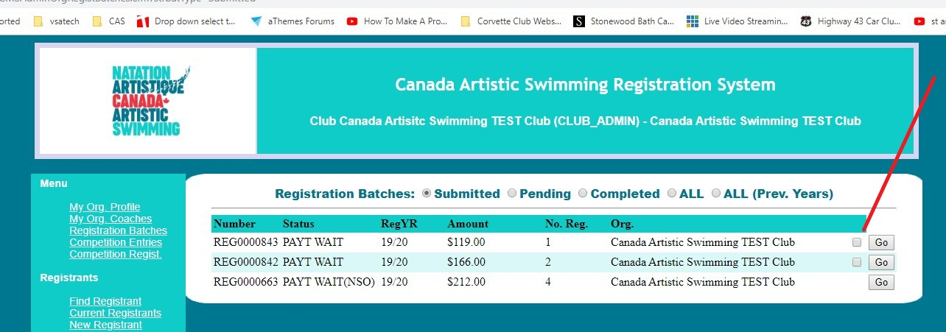

Once you select at least 1 batch, the “Payment Summary Report” button appears. You can select and remove selection as required. You can select more than 1 batch as well.

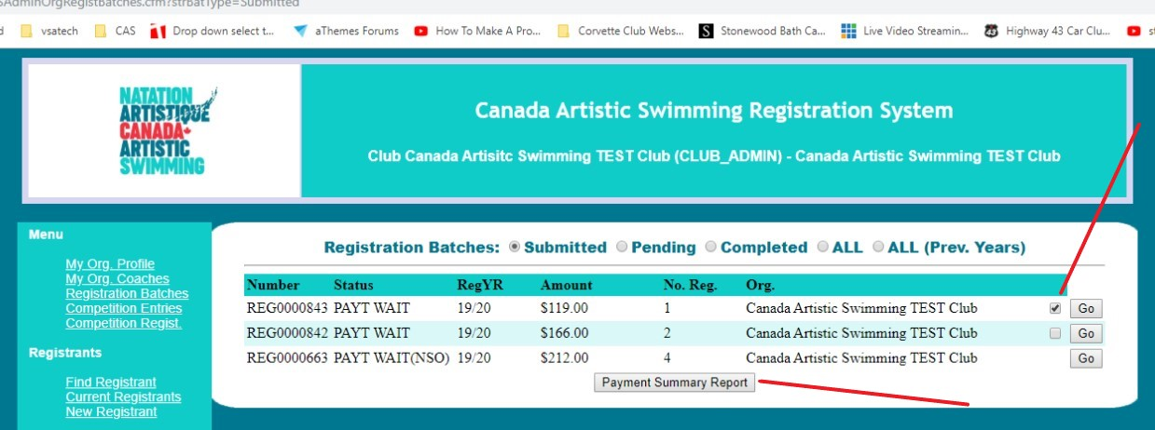

Once you click the “Payment Summary Report” button, the report appears on the screen for all batches selected.
You can print or save the report as a PDF. The following is an example of the club report.

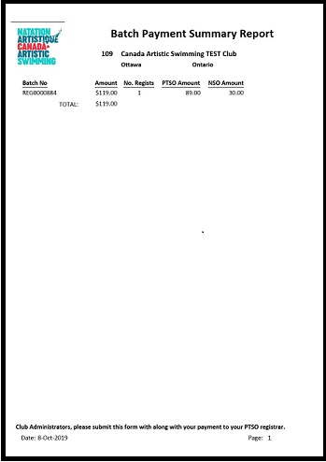

In the example below, the first batch shows an “S” which means it already was printed on a payment summary report. You can check it again if you require it on another payment summary report.
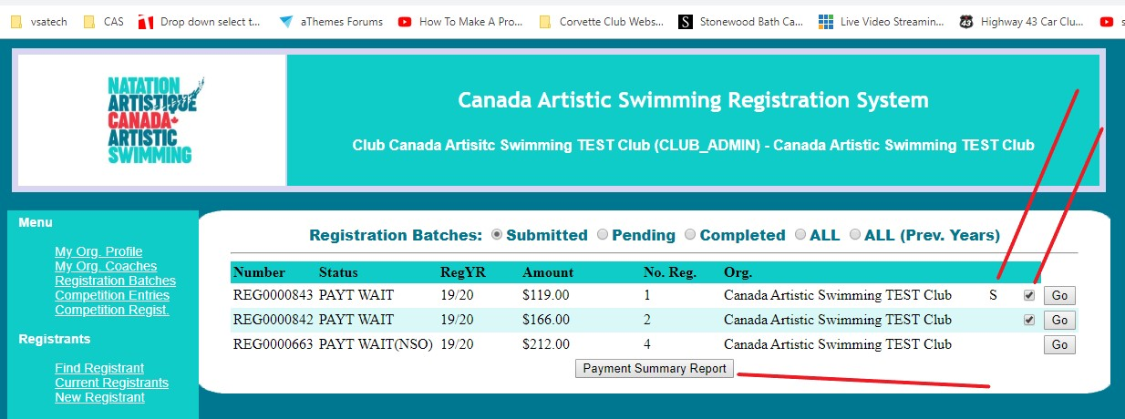

PTSO Payment Summary Report Screens
List of batches for a PTSO, only “PAY WAIT(NSO)” (payments submitted by PTSO) can be printed on the payment summary report. These will have the check boxes beside the “Go” button. You can check these on and off as desired.

In the example below, only batches with “PAY WAIT(NSO)” status have the check box for selection.

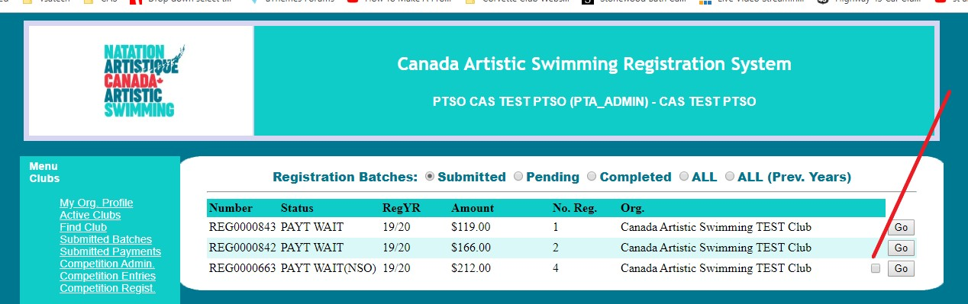

Once a batch has been checked, the “Payment Summary Report” button appears. You can select as many batches for payment as you need. The “S” beside the first batch indicates it has already been printed on a payment summary report.

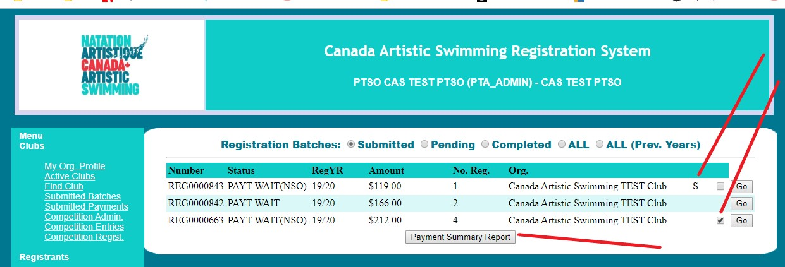

PTSOs can also submit registrant payments in this manner by going to the “Submitted Payments” screen and selection payments with “PAY WAIT(NSO)” status. This functions the same as the batches screen. You can enter payments and batches onto the same payment summary report by going to both screens, select batches and payments and then on either screen click the “Payment Summary Report” button to display the report.

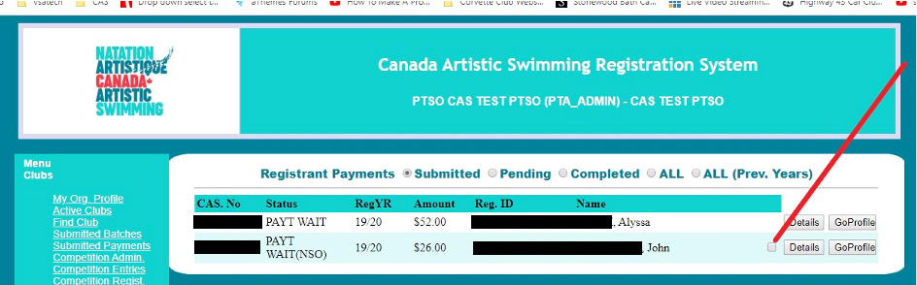

An example of a payment selected and the payment summary report button appearing.

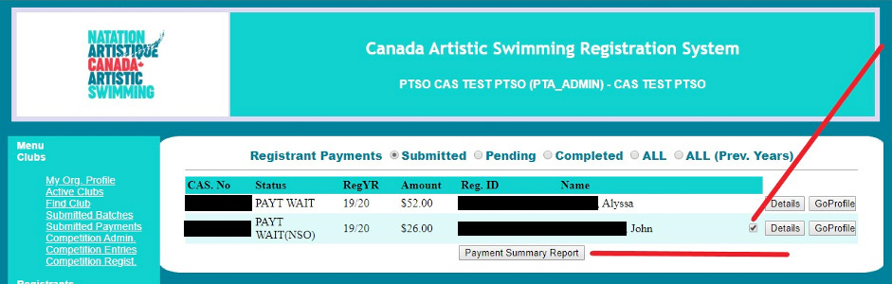

An example of the PTSO Payment Summary report for submission to CAS with only individual payments noted.

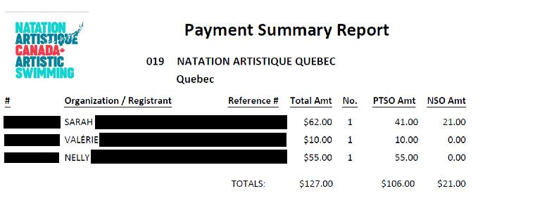

An example of the “S” indicating that the payment has appeared on a payment summary report. Similar to the batch payment selection.

